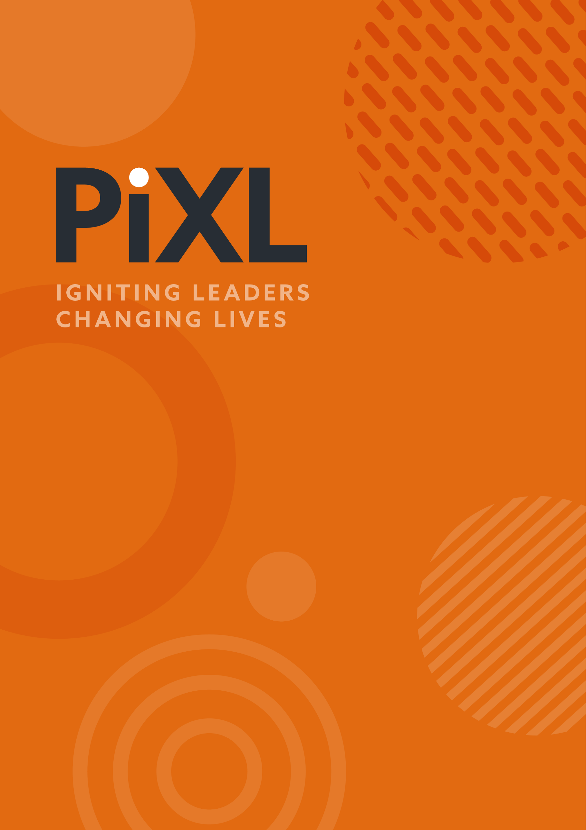

PEARL LEADERSHIP PROMPTS
SERIES 9
EPISODE 2: Unintended Opportunities
For discussion in your teams or for your own personal reflection.
- Things were clearly going very wrong for Milton Bradley and his business, yet out of a difficult situation, something new was born.
- When things are going wrong, people respond very differently. How does the team you work in respond to challenging situations?

- How would you WANT your team to behave when you have to face difficult things? Write down the behaviours you may want to see below.

For an idea on how to unpick situations when things go wrong, look at the concept of an ‘autopsy without blame’ and an ‘After Action Review’, used widely in Business and in the Armed Forces.
- We will have made decisions that sometimes have unintended consequences as well as unintended opportunities.
How can we better see the potential ‘unintended consequences’ of decisions we are making? For example, conduct a pre-mortem, consult with stakeholders, create a shadow board of different people to see their reaction. What else do you do?

- The story of Grace, Abraham and Milton is a great story. All 3 people are connected by the consequences and opportunities that came as the result of that letter. Being able to go back over our experiences and construct a narrative that makes sense of what we have experienced, is important. Think back in your life to a time when something unexpected happened that had consequences (which at the time, may have not been good). Now look at where you are today. Construct the story that connects the two things. What is the story you are telling yourself?



© The PiXL Club Ltd. 2025. All Rights Reserved.
This resource is strictly for the use of The PiXL Club (“PiXL”) subscribing schools and their students for as long as they remain PiXL subscribers. It may NOT be copied, sold, or transferred to or by a third party or used by the school after the school subscription ceases. Until such time it may be freely used within the PiXL subscribing school by their teachers and authorised staff and any other use or sale thereof is strictly prohibited.
All opinions and contributions are those of the authors. The contents of this resource are not connected with, or endorsed by, any other company, organisation or institution.
This resource may contain third party copyright material not owned by PiXL and as such is protected by law. Any such copyright material used by PiXL is either provided under licence or pending a licence.
PiXL endeavour to trace and contact third party copyright owners. If there are any inadvertent omissions or errors in the acknowledgements or usage, this is unintended and PiXL will remedy these on written notification.

