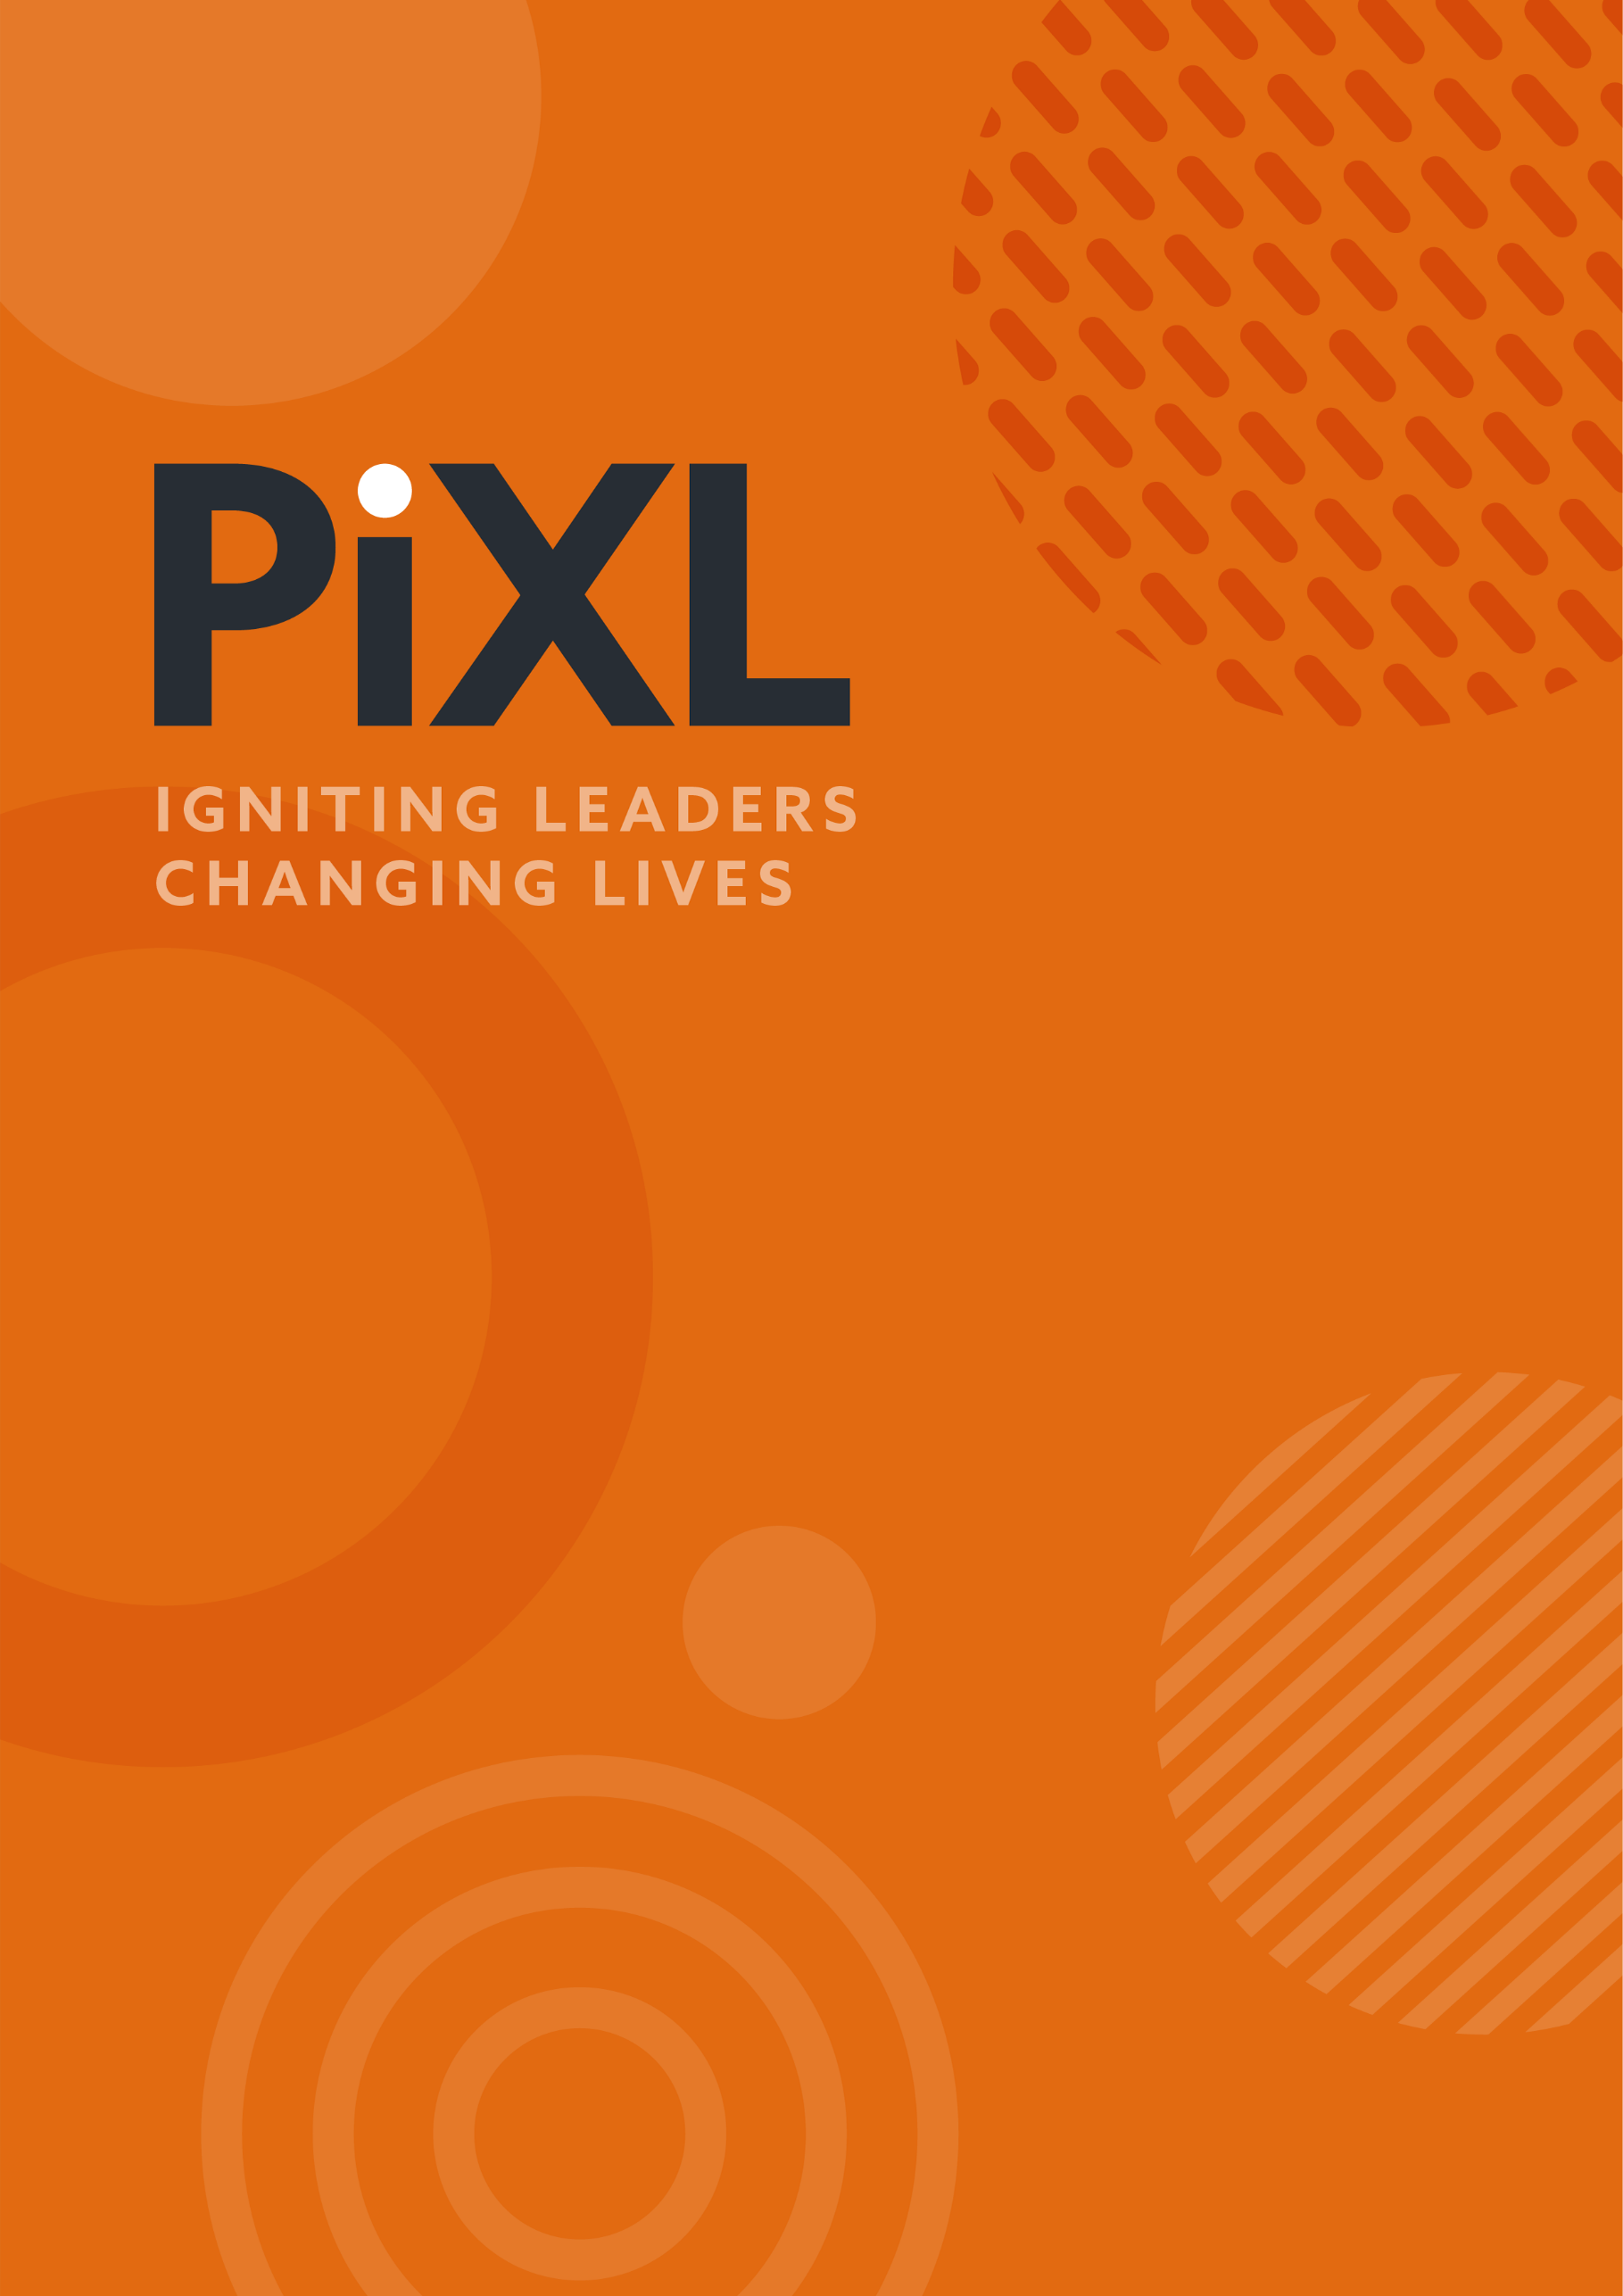

PEARL LEADERSHIP PROMPTS
SERIES 9
EPISODE 3: Taylor
For discussion in your teams or for your own personal reflection.
- Taylor Swift’s world-record breaking ‘Eras’ tour was a clever representation of the different stages of her musical life. There were different sounds, different looks, different emotions and contexts in each era. The idea of ‘eras’ is a helpful concept for us too.

- Individually, go back through the decades of your life and give each one a word that sums up that decade now that you look back with hindsight. For example, your first 10 years may have been the ‘settled era’, the next one was more about your ‘identity era’, the next one your ‘disruption era’.

- In your leadership, what eras have your team been through? It may be far less than a decade, it may have lasted months or only a few years. Was the start of your leadership your ‘discovery era’, then the ‘confident era’ then the ‘daring era’ or something else? As a team, what are the eras you have been through together and what might the era be that you are entering into now?

- Taylor Swift is known for her musical ability but also her acute business sense. It appears that she can find a place where no-one else sits and knows how to move into it. Swift innovates, seems to be happy with vulnerability and mistakes, and can think very differently to others in her industry. She lives in the ‘blue ocean’.
As a team, how good are you at finding the ‘blue ocean’ – the place where we can question the status quo, challenge what we are told and ask questions of what is expected of us and then start to think differently, to pioneer and to innovate? What evidence do you have in your team of ‘blue ocean’ thinking?

- Taylor Swift has not always made choices that have been universally accepted. Sometimes she has been accused of being ‘calculating’, sometimes being too vulnerable and sometimes taking a feud too far, releasing ‘diss-tracks’ (short for ‘disrespect tracks’) to get at the other person. The way she has handled her ambition and drive, her emotions and her conflicts have been scrutinised in countless articles.
As a team, how do we navigate our:
- ambition?
- vulnerability?
- conflicts?
What is our playbook as to how we handle these things between us as a team and as a team with our wider stakeholders?



© The PiXL Club Ltd. 2026. All Rights Reserved.
This resource is strictly for the use of The PiXL Club (“PiXL”) subscribing schools and their students for as long as they remain PiXL subscribers. It may NOT be copied, sold, or transferred to or by a third party or used by the school after the school subscription ceases. Until such time it may be freely used within the PiXL subscribing school by their teachers and authorised staff and any other use or sale thereof is strictly prohibited.
All opinions and contributions are those of the authors. The contents of this resource are not connected with, or endorsed by, any other company, organisation or institution.
This resource may contain third party copyright material not owned by PiXL and as such is protected by law. Any such copyright material used by PiXL is either provided under licence or pending a licence.
PiXL endeavour to trace and contact third party copyright owners. If there are any inadvertent omissions or errors in the acknowledgements or usage, this is unintended and PiXL will remedy these on written notification.

