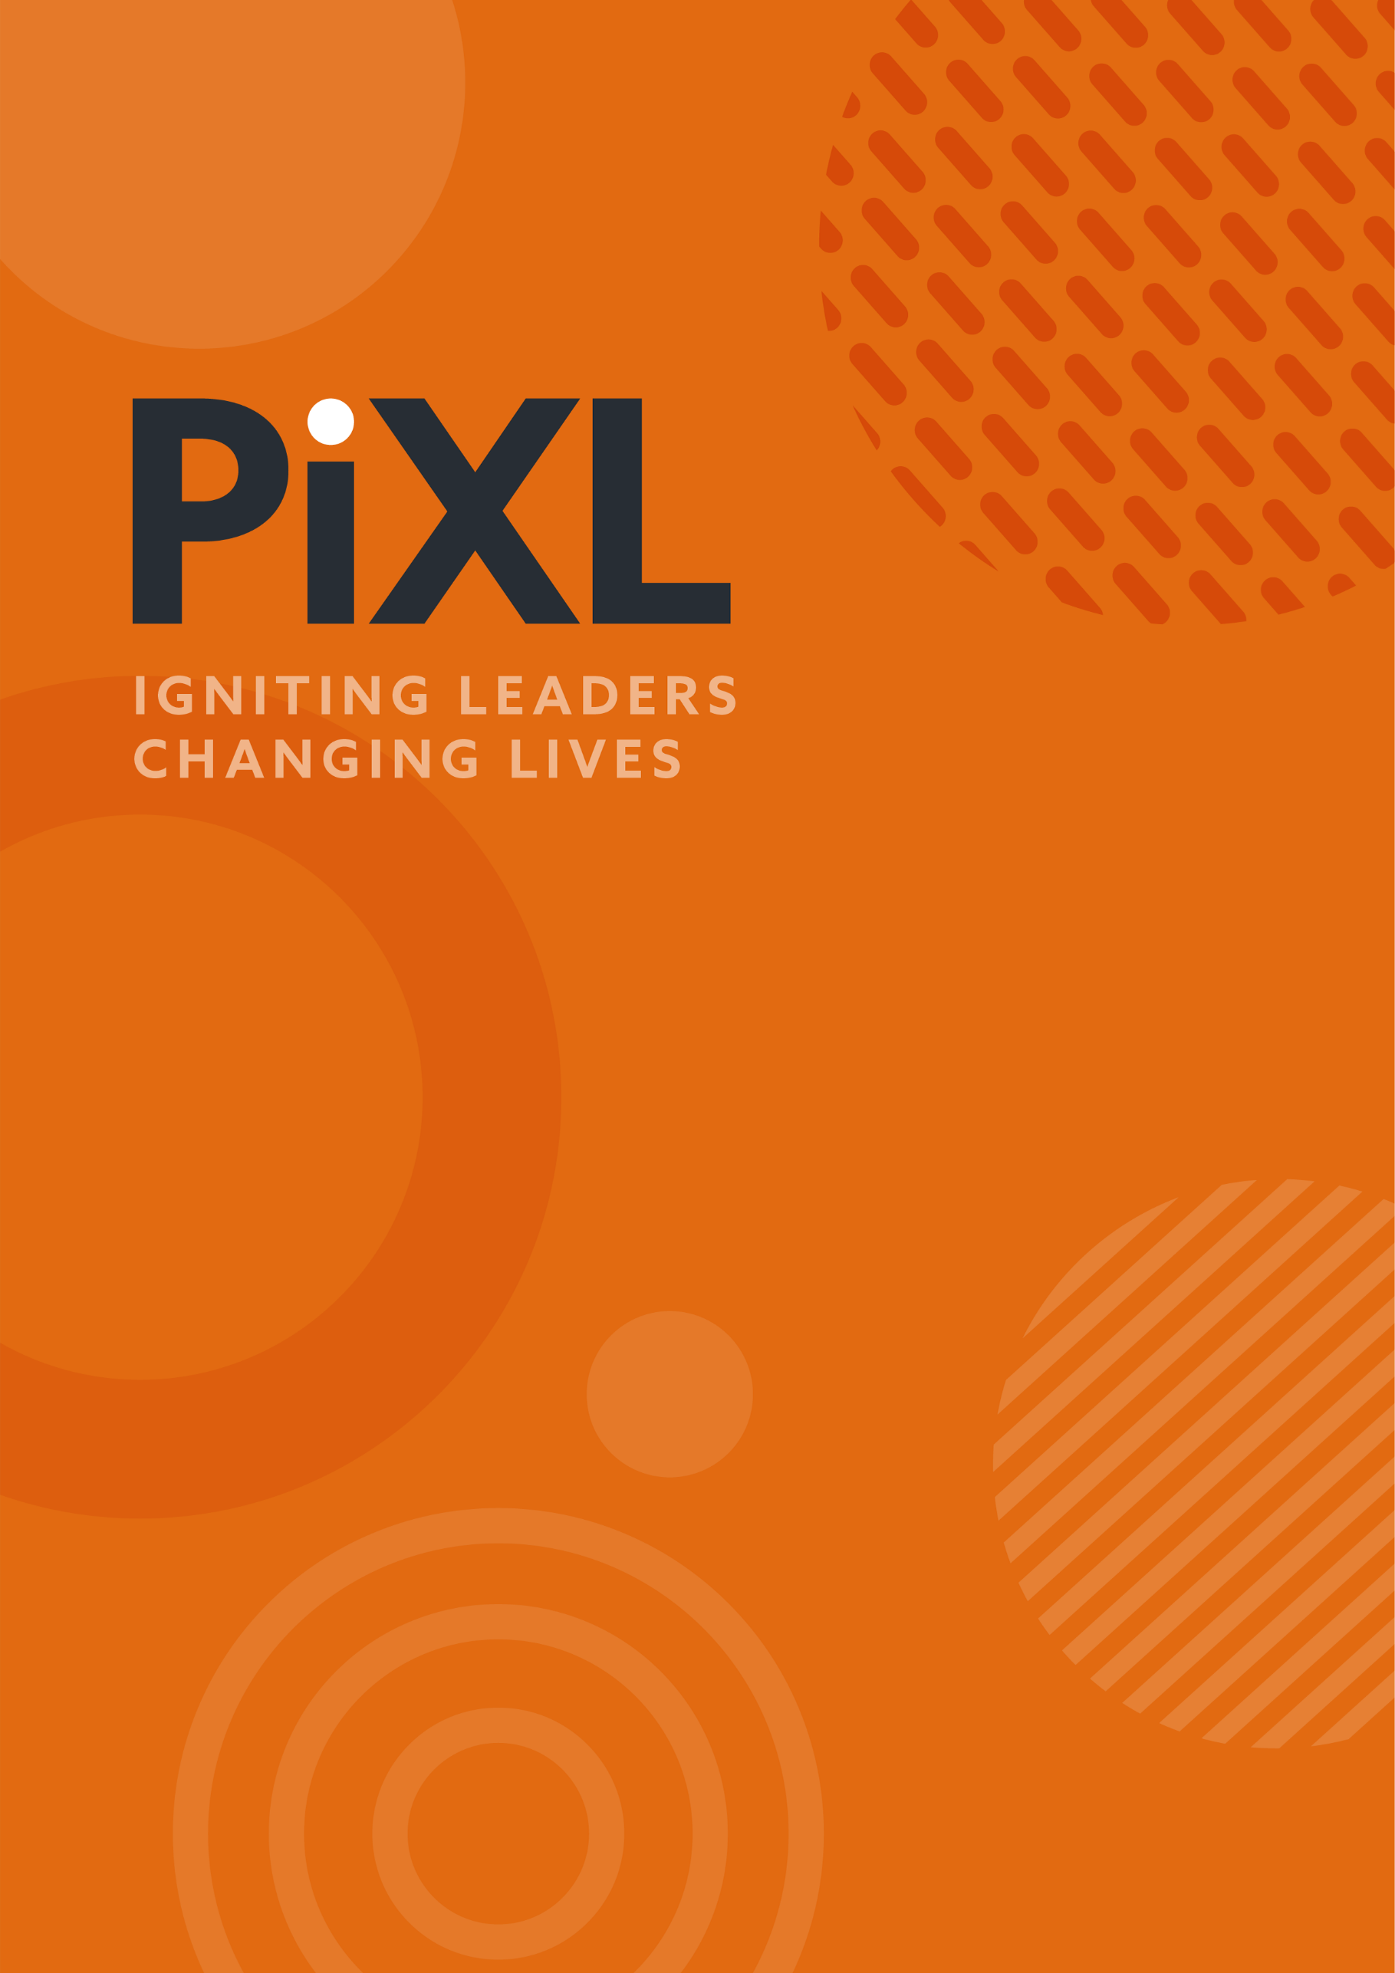

PEARL LEADERSHIP PROMPTS
SERIES 9
EPISODE 8: SORRY
For discussion in your teams or for your own personal reflection.
- Saying sorry is not very easy at times. In your team, how do people admit mistakes, express regret for a mis-step or acknowledge their contribution to someone’s distress?

- There is much talk of Amy Edmondson’s work on ‘psychological safety’ at the moment in leadership, and rightly so. Being able to admit mistakes and say sorry is a key part of people feeling safe and cultures being positive and open places to work. In teams that are psychologically safe, people:
- treat mistakes as information, not as failures of character.
- report problems early
- accountability and blame are not the same thing
- they acknowledge where things have gone wrong
- analyse the system or process which has contributed to it
- commit to a change
- say, ‘here is what I got wrong and here is how I would have done that differently’

By this criteria, how ‘psychologically safe’ is your team and what is your evidence? Give examples.

- In Ron Lewicki’s research on apologies published in the Journal of Negotiation and Conflict Management Research, he outlines the ingredients of an apology.
- Acknowledgement of responsibility — the single most important element
- Offer of repair — committing to fix the damage
- Expression of regret
- Explanation of what went wrong
- Declaration of repentance — commitment not to repeat it
- Request for forgiveness — the least important element
Which stages do you/your team do the best? And where is there room for improvement? What would be different if we all got this right?

- The research shows there is an interesting distinction around the type of wrongdoing. Participants were less likely to accept an apology when the wrongdoing reflected a lack of integrity rather than a lack of competence. In other words, if you knowingly do something wrong, the apology does not land in the same way than if you honestly made a mistake. These two things are different, do you respond differently to each of them.



© The PiXL Club Ltd. 2026. All Rights Reserved.
This resource is strictly for the use of The PiXL Club (“PiXL”) subscribing schools and their students for as long as they remain PiXL subscribers. It may NOT be copied, sold, or transferred to or by a third party or used by the school after the school subscription ceases. Until such time it may be freely used within the PiXL subscribing school by their teachers and authorised staff and any other use or sale thereof is strictly prohibited.
All opinions and contributions are those of the authors. The contents of this resource are not connected with, or endorsed by, any other company, organisation or institution.
This resource may contain third party copyright material not owned by PiXL and as such is protected by law. Any such copyright material used by PiXL is either provided under licence or pending a licence.
PiXL endeavour to trace and contact third party copyright owners. If there are any inadvertent omissions or errors in the acknowledgements or usage, this is unintended and PiXL will remedy these on written notification.

